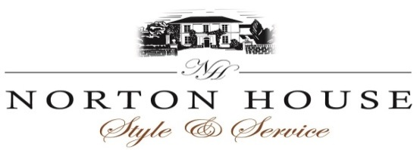
Buffet Menu
Hog Roast
(Minimum 80 guests)
Stuffing
Baps
Apple sauce
Mixed leaf salad
Feta and tomato salad
Potato salad
Coleslaw

£21.00 per person

Finger Buffet Selection
Selection of sandwiches Mini Pastry Cases Filled with Prawn
Honey and Sesame seed covered chicken drumsticks Deep Fried Whitebait
Potato wedges Deep Fried Calamari
Mini BBQ Spare ribs Sausage rolls
Smoked Salmon and Cream and Chive Swirls Spicy chicken wings
Mini Chipolata sausages Mini Fish Bites
Cucumber topped with Tomato and cream cheese Onion rings
Tomato and feta skewers Sweet Potato Fries
Italian Meatballs Tomato Sauce
Olives and Sun Dried Tomato
Mini Pastry Cases Filled with Prawn Marie Rose Sauce
9 items £13.00 per person
11 items £15.00 per person
Includes Mint Yoghurt, Chutneys, Mayonnaise and Tomato Sauce

Fork Buffet Selection
(Minimum 40 guests)
Buffet 1 at £17.00 Buffet 2 at £19.00
Beef & Ale Pie Chicken, Leek, Bacon and Cream Pie
Chicken Strogonoff Vegetarian Lasagne
Cold Roast Honey Ham Fish Pie
Crown of Roast Turkey Poached Salmon and cold water
Crusty Bread prawns
Roast Sirloin of Beef
Crusty bread

The following are included with Buffet 1 & 2
Coriander Rice, New Potatoes, Salads, Mixed Leaves, Tomato and Onion, Pasta and Pesto, Coleslaw, Feta and Cucumber
Selection of dressings

Strawberry Cheesecake, Eton mess, Profiteroles.

Please inform a member of staff if you have any specific dietary requirements

